
Computing Newsletter
Autumn Term 1

Welcome to the Computing newsletter. I aim to send one of these out each half term to you so that you can see what your children will be learning about in Computing.
Please also be on the lookout for a separate online safety newsletter. This will be looking at what we have been doing in school with regards to online safety and providing you with more information about various aspects of online safety.

How we teach computing at Annie Lennard

Computing is a vital part of the curriculum and allows prepare the children to help them navigate and be safe in an ever developing and growing technological world. There are three aspects of computing. Across the year, the children explore all three aspects of computing multiple times to ensure they are able to develop the range of skills and knowledge needed.
The three aspects are;

Computer Science - How computers and computer systems work and how they are designed and programmed.
Information Technology – Using existing programs to develop products and solutions using existing programs in a purposeful way. This can include making podcasts, taking photos or creating digital art.
Digital Literacy – Developing the skills, knowledge and understanding needed in order to participate fully and safely in an increasingly digital world

We follow the Teach Computing scheme of work which allows for a progressive curriculum for the children and is approved by the Department for Education.
The children work on a range of technologies including Chromebooks, iPads, Laptops, Crumbles and Micro-bits.

All children from Y1-Y6 have a Computing books where some of their work is recorded as well as access to a digital folder in a Google Drive. The children take these books through school with them which gives the children the opportunity to look back at their previous learning for each topic, allowing them to build on it in their current year group.

Online Safety

Online Safety is a huge part of school life and is consistently and constantly covered in computing lessons.

Every half term, the children complete an online safety mind map where they are asked to tell us what they do online. These are then used to help inform the teaching of online safety and also to help train staff to help develop their subject knowledge on what our children do online. In the online safety newsletter each half term, information from this will be shared with you so you can see what is popular at school and what to look out for.
Every lesson, the children take part in a 10 minute online safety every lesson where they focus on one of 8 focus areas. These focus areas are;
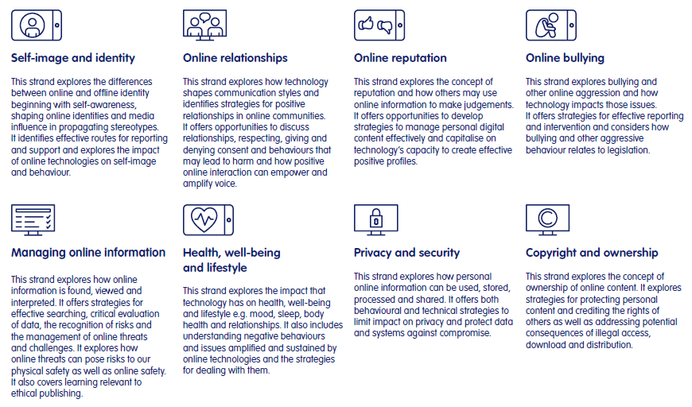
We also do celebrations in school each half term linked to online safety.
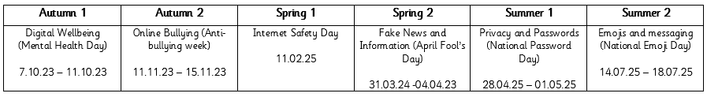
Online safety is recorded in the children’s books and as part of the whole class book that moves with them as they go through school.

Autumn 1 – Networks and Technology Around Us.

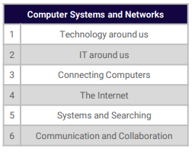
The Computer Systems and Networks strand is taught once a year, building progressively from one year group to the next, with subject specific knowledge introduced at age-appropriate points. This area allows the children to understand how computers and networks work. The children begin in Y1 and Y2 looking at the types of technology around us before looking at how it is used in the wider world. In Y3 and Y4, the children develop their understanding by exploring what a network is and how computers are connected as well as what the internet is and how it works. In Y5 and Y6, the children look at search engines and how we can use networks and technology to communicate with each other and collaborate to achieve a goal.

Year 1 – Technology Around Us
The children will develop their understanding of technology and how it can help them in their everyday lives. They will start to become familiar with the different components of a computer by developing their keyboard and mouse skills. They will also consider how to use technology responsibly and who to ask for help if they see any content or comments online that make them feel uncomfortable.
Year 2 – IT Around Us
The children will develop their understanding of what information technology (IT) is and will begin to identify examples. They will discuss where they have seen IT in school and beyond, in settings such as shops, hospitals, and libraries. They will then investigate how IT improves our world, and they will learn about the importance of using IT responsibly.
Year 3 – Connecting Computers
The children will develop their understanding of digital devices, with an initial focus on inputs, processes, and outputs. They will also compare digital and non-digital devices. Next, they will be introduced to computer networks, including devices that make up a network’s infrastructure, such as wireless access points and switches. Finally, they will discover the benefits of connecting devices in a network.
Year 4 – The Internet
The children will apply their knowledge and understanding of networks, to appreciate the internet as a network of networks which need to be kept secure. They will learn that the World Wide Web is part of the internet, and will be given opportunities to explore the World Wide Web for themselves in order to learn about who owns content and what they can access, add, and create. Finally, they will evaluate online content to decide how honest, accurate, or reliable it is, and understand the consequences of false information.
Year 5 – Systems and Searching
The children develop their understanding of computer systems and how information is transferred between systems and devices. Children will consider small-scale systems as well as large-scale systems. They explain the input, output, and process aspects of a variety of different real-world systems. They also discover how information is found on the World Wide Web, through learning how search engines work (including how they select and rank results) and what influences searching, and through comparing different search engines
Year 6 – Communication and Collaboration
In this unit, the children explore how data is transferred over the internet. They initially focus on addressing, before they move on to the makeup and structure of data packets. They then look at how the internet facilitates online communication and collaboration; they complete shared projects online and evaluate different methods of communication. Finally, they learn how to communicate responsibly by considering what should and should not be shared on the internet and how to report concerns about inappropriate content online.
.

